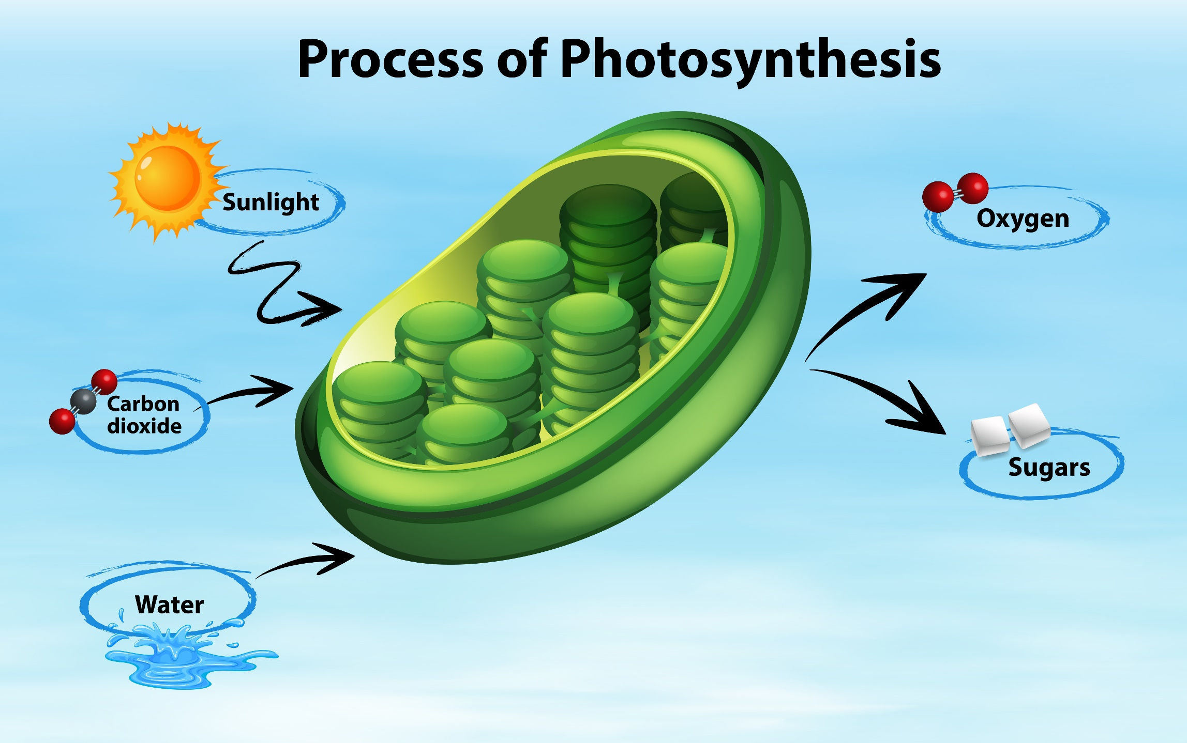

FOTOSYNTÉZA



<https://www.freepik.com/free-vector/diagram-showing-process-photosynthesis_1553557.htm>

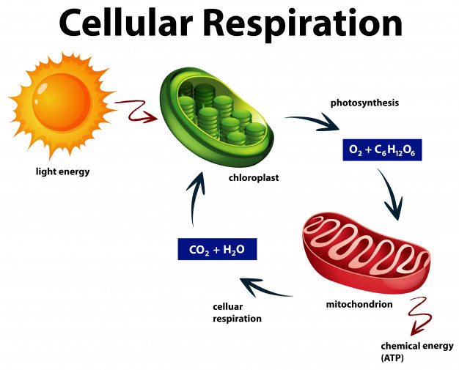

BUNĚČNÉ DÝCHÁNÍ

<https://www.freepik.com/free-vector/diagram-showing-cellular-respiration_1817796.htm#&position=2>